**Circles**

# Introduction to Circle

A **circle** is the locus of a point which lies in the plane in such a manner that its distance from a fixed point in the plane is constant. The fixed point is called the **centre** and the constant distance is called the **radius** of the circle.

# Parts of the circle

* + A line segment that joins any two points lying on a circle is called the **chord** of the circle.
  + A chord passing through the centre of the circle is called **diameter** of the circle.
  + A line segment joining the centre and a point on the circle is called **radius** of the circle.
  + A line which intersects a circle at two distinct points is called a **secant** of the circle.

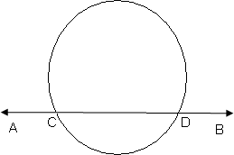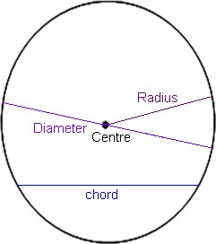

In the figure, AB is a secant to the circle.

# Tangent to the circle

A **tangent** to the circle is a line that intersects the circle (touches the circle) at only one point. The word ’tangent’ comes from the Latin word ‘tangere’, which means to touch. The common point of the circle and the tangent is called **point of contact**.

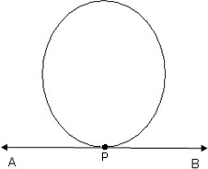

In the figure, AB is a tangent to the circle and P is the point of contact.

# Important facts about tangent

* + The tangent to a circle is a special case of the secant, when the two end points of its corresponding chord coincide.
  + The tangent at any point of a circle is perpendicular to the radius through the point of contact. This point of contact is also called as point of tangency.

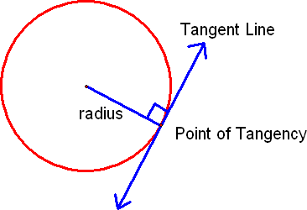

* + A line drawn through the end of a radius (point on circumference) and perpendicular to it is a tangent to the circle.

# Number of tangents on a circle

* + There is no tangent possible to a circle from the point (or passing through a point) lying inside the circle.
  + There are **exactly two tangents** possible to a circle **through a point outside the circle**.
  + At any point on the circle, there can be one and only one tangent possible.

# Length of the tangent

The length of the segment of the tangent from the external point P and the point of contact with the circle is called the **length of the tangent**.

* + The lengths of tangents drawn from an external point to the circle are equal.
  + The figure shows two equal tangents (*PA = PB*) from an external point *P*.

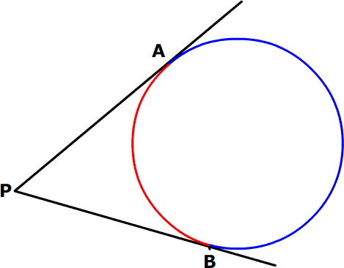

# Angle between two tangents from an external point

* + The centre of a circle lies on the bisector of the angle between the two tangents drawn from an external point.
  + 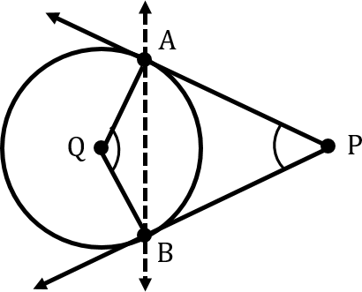Angle between two tangents drawn from an external point to a circle is supplementary to the angle subtended by the line segment joining the points of contact at the centre.

In the figure, angle P and angle Q are supplementary.

# Perpendicular from the centre

Perpendicular drawn from the centre to any chord of the circle, divides it into two equal parts. In the figure, OM is perpendicular to AB and AM = MB.

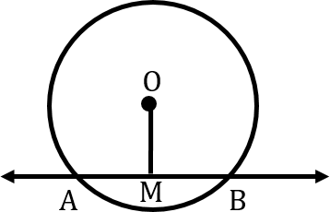

# Normal to the circle

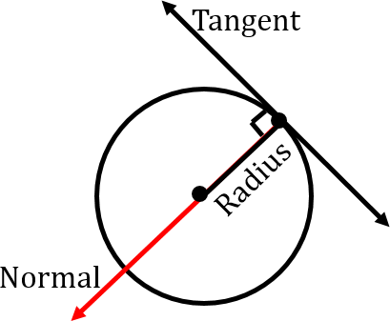The line containing the radius through the point of contact is called the normal to the circle at that point.

# Inscribed circle

Opposite sides of a quadrilateral circumscribing a circle subtend supplementary angles at the centre of the circle.

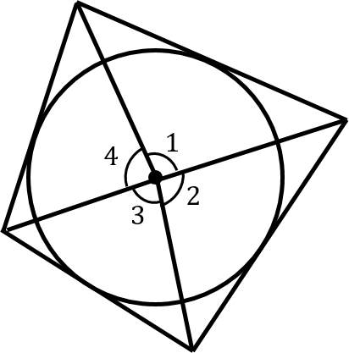

In the figure, angles 1 and 3 are supplementary. Accordingly, angles 2 and 4 are supplementary.